Tutorial 03. JavaScript Debug
V1.0
26/09/2021
Now we have started programming with JavaScript. You could use JavaScript to manipulate HTML and CSS. In order to use JavaScript to solve more complex problems, it is important to study data structures (e.g. array) and algorithms (e.g. sort and search). Before we get started with these topics, we should study basic debugging methods using browser embedded debugger tool. In this tutorial, we will learn what is debugger tool, and use some examples to walkthrough the process. Below are the topics of this tutorial.
Topics
1. What debugger can do 1
2. How to use JavaScript debugger 2
Step 1. Prepare the code 2
Step 2. Test the functions 3
Step 3. Open JavaScript file in developer tool 3
Step 4. Set breakpoint 3
Step 5. Run function again in console tab 4
Step 6. Step through the execution 4
Step 7. Watch the “Scope” window 5
Exercise 1 – debug a function with “branches” 5
Exercise 2 – debug a function with “loop” 5
Challenge 1 6
Challenge 2 6

- What debugger can do
Debugger tools used for any programming languages share the same principles and concepts. Below are the common operations when using debugger for troubleshooting.
- Setting breakpoint – You set breakpoints wherever you want to pause debugger execution. For example, you may want to see the state of code variables or look at the call stack at a certain breakpoint.
- Stepping through code– Stepping through your code enables you to walk through your code's execution, one line at a time, and figure out exactly where it's executing in a different order than you expected.
- Check variable values - When you're paused on a line of code, the debugger tool shows you what local and global variables are currently defined, along with the value of each variable.
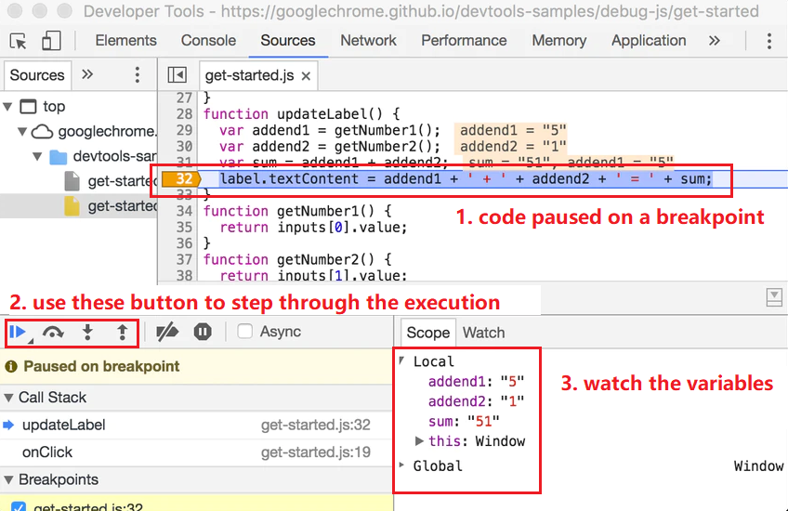
Let’s use browser embedded debugger tool to learn JavaScript troubleshooting.
- How to use JavaScript debugger
  - Prepare the code
Code the following HTML and JavaScript code and launch the web page with Google Chrome.
index.html | myscript.js
<!DOCTYPE html>  <html>  <body>  <script src="./myscript.js"></script>  </body>  </html> | function fun1(){  let i = 0;  i += 1;  i += 2;  i += 3;  i += 4;  i += 5;  return i;  }  function max(a, b, c){  let max;  if (a >= b) {  if(a >= c) {  max = a;  } else {  max = c;  }  } else {  if(b >= c) {  max = b;  } else {  max = c;  }  }  return max;  }  function sum1ToN(n){  let sum = 0;  for (let i = 1; i <= n; i++) {  sum = sum + i;  }  return sum;  }

  - Test the functions
Open the webpage and launch developer tool. In the console tab, test the three functions as below.
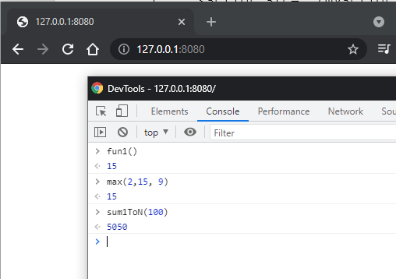
  - Open JavaScript file in developer tool
In the developer tool open “Source” tab locate the myscript.js open it as below
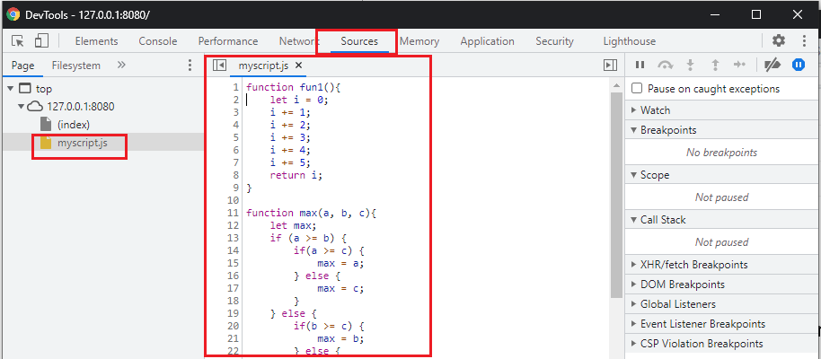
  - Set breakpoint
Let’s say “fun1” did not work as expected and we want to what was happening when this function get executed. Setting a breakpoint is the first step for debugging.
Left click the line number on the code view to set a breakpoint, and we want to pause the code execution on this line. Let’s set a break point at line No. 2, which is the first line of code of fun1().
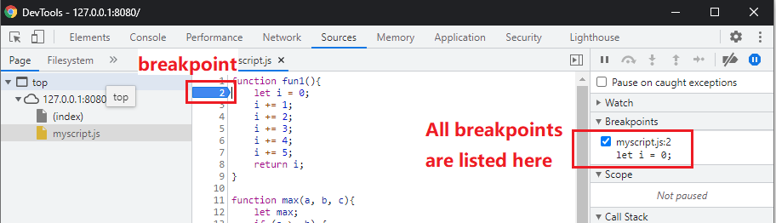
  - Run function again in console tab
In the console tab, run the fun1() again. The execution shall pause on the breakpoint, and develop tool will automatically switch to Sources tab and show you that a breakpoint was hit.
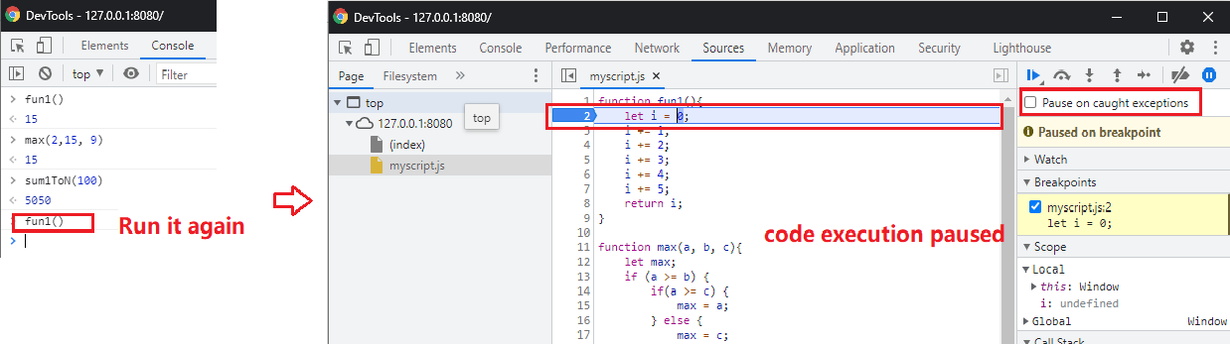
  - Step through the execution
When the execution paused, the “step through” buttons are enabled. Use this tutorial to study the details of each button later. In this part we are going to use the “step over” button to run the code step by step.
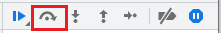
Now click on the “step over” button once, and the debugger shall finish the execution on current line on the breakpoint and pause on the next line. Check the value of variable “i” in the “Scope” window, as below.
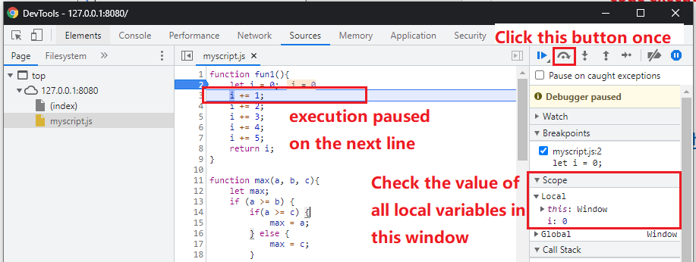
  - Watch the “Scope” window
Use the step over button to execute all the lines in the function, while watching how the value of variable “i” changes. And this is the basic method of debugging using a debugger.
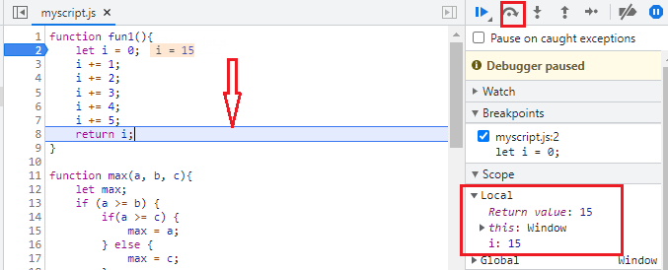

Exercise 1 – debug a function with “branches”
Function max(a, b, c) has if condition structure. Debug this function with the method above
Set breakpoint run the function step through the execution
Note: call the function multiple times with different parameters to cover different path each time

Exercise 2 – debug a function with “loop”
Function sum1ToN(n) has for loop structure. Debug this function with the method above
Set breakpoint run the function step through the execution
Note: watch how and when the three statements in the for syntax get executed.
- Statement 1 shall be called at the very beginning for just one time
- Statement 2 shall be called each time before going to the code block
- Statement 3 shall be called each time the code block is finished.

Challenge 1
You have done some JavaScript programming in previous labs. Use the method above to debug the codes.

Challenge 2
Use this tutorial to study the details of each button. Try to use each button in the debugging process, to see how each of them work. You may need to design some function for further test.
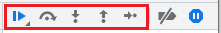

End of this tutorial

